Number to be given in program

Synthesis of hydroxyapatite by an aqueous precipitation method using gypsum as a calcium source
L. Braga Dantas1, V. Scarpini Candido1, M. H. Prado da Silva1
¹ Military Institute of Engineering, Materials Science and Engineering Graduate Programme, Rio de Janeiro, Brazil

Introduction
Hydroxyapatite, Ca10(PO4)6(OH)2 (HA or Hap), stands out as one of the most widely used biomaterials, especially in the context of bone tissue engineering. This material can be found in nature or obtained by chemical synthesis, and its properties, including shape, size, crystalline structure, and applications, vary signiﬁcantly depending on the source and the methods of obtaining it [1, 2]. Diﬀerent approaches have been developed for the synthesis of hydroxyapatite, ranging from conventional chemical methods, such as precipitation and sol-gel, to more recent techniques, such as microwave-assisted synthesis and atomic layer deposition. Each of these routes has advantages and limitations, which makes it essential to understand the role of synthesis conditions in determining the ﬁnal properties of the material [1, 2, 4, 5]. In this scenario, nanometric hydroxyapatite (HA-NM or nHAp) has stood out as a highly relevant material, not only for its stability as calcium phosphate, but also for its applicability as a vehicle for controlled release of substances, coating material, and implantable component [1, 2]. Its properties are strongly dependent on synthesis conditions, such as pH and temperature, which directly inﬂuence its structure, morphology and functional performance [1-4]. The present study presents a sustainable route for the synthesis of hydroxyapatite from calcium sulfate dihydrate, CaSO4.2H2O (gypsum).

Methods
Hydroxyapatite (HA) synthesis was carried out using the aqueous chemical precipitation route, a method widely employed due to its simplicity, low operational cost, and ability to produce powders with high chemical purity and controlled composition, as seen in the literature review. Traditionally, this methodology uses calcium hydroxide [Ca(OH)₂] as a source of calcium ions (Ca²⁺); however, in this study, calcium sulfate (CaSO₄) was chosen as the substitute for this precursor, aiming to evaluate its applicability as an alternative source of calcium in obtaining the hydroxyapatite phase.[2] The use of calcium sulfate as a calcium precursor is based on its wide availability, low cost, biocompatibility, and potential for use in gypsum-based waste recycling processes, contributing to the development of more sustainable synthesis routes for obtaining calcium phosphate-based biomaterials.[2] The quantities of reagents were calculated based on the reaction stoichiometry and the characteristic calcium/phosphorus (Ca/P) molar ratio of stoichiometric hydroxyapatite, equal to 1.67, corresponding to the chemical formula Ca₁₀(PO₄)₆(OH)₂.
During the synthesis process, the experimental parameters were rigorously controlled, including the proportions between the reagents, the dilution conditions, the pH of the reaction medium, the temperature, and the rate of addition of the precursor solutions. These factors directly inﬂuence the nucleation and crystal growth mechanisms, aﬀecting the phase purity, crystallinity, morphology, and size of the particles obtained. Thus, controlling the synthesis variables was fundamental to favoring the formation of hydroxyapatite and minimizing the occurrence of undesirable secondary phases.[2]
The powders were characterized by X-ray diﬀraction (XRD) and ﬁeld emission scanning electron microscopy (FE-SEM) with energy-dispersive X-ray spectroscopy (EDS). A Panalytical X-Pert Pro X-ray

diﬀractometer was used with CuKα radiation (λ = 1.5406 Å), a 2θ scanning range of 10° to 60°, a step size of 0.02°, and a scanning speed of 2° min−1. FEG-SEM analyses were performed on a FEI Quanta FEG-250 instrument.

Results
During the preparation of the precursor solution, the formation of a suspension was observed. The decanted powder was characterized by SEM and XRD. Figure 1 shows the morphology of the powder observed in FEG-SEM and the EDS spectrum after the preparation of the precursor suspension, at pH=3.5. Acicular precipitates were observed, and EDS identiﬁed the presence of Ca, P, and S.
X-ray diﬀraction analysis of these powders revealed the presence of brushite (JCPDS 00-009-0077) and calcium sulfate hydrate (JCPDS 01-072-0596), Fig. 2.
After adding KOH and adjusting to pH=12, the powders were analyzed by FEG-SEM/EDS and XRD. FEG-SEM analyses revealed a strong change in morphology, showing nanometric precipitates. EDS indicated the presence of Ca and P. The X-ray analysis indicates the presence of the hydroxyapatite phase (JCPDS
09-0432).

Conclusion
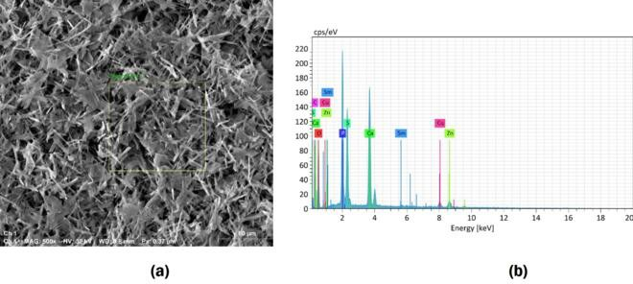
Hydroxyapatite was using gypsum as a calcium source. The morphology of the ﬁnal powder may be controlled according to the synthesis parameters. A gypsum-HA composite can also be obtained, and it is a promising material to be used as bone ﬁller. Biphasic calcium phosphate grafts composed of HA and TCP can also be prepared by heat treatment of the obtained powders.

FEG-SEM micrograph showing acicular precipitates (a) and EDS spectrum (b).

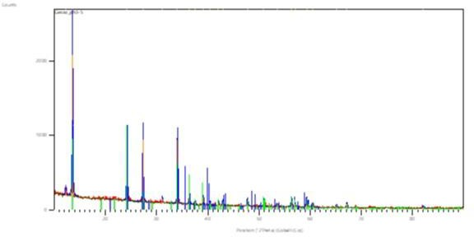

Figure 2 - X-ray diﬀraction pattern of the decanted powder.

